Nom : ……………………………. Date : …………………………….
CP

Lecture
Fiche
L4

Mots fléchés [l] l



lapin – luge – locomotive – chocolat – vélo – lune - livre

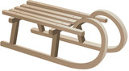
 |  |  | 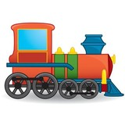 |  |  |  |  |  | 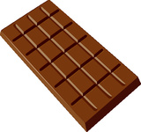
 |  |  |  |  |  | 
 |  | 
 |  |  |  |  | 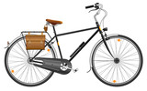
 | 
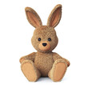
 |  |  |  |  |  |  |  |  |  | http://www.i-profs.fr

Nom : ……………………………. Date : …………………………….
CP

Lecture
Fiche
L4

Mots fléchés [l] l

lapin – luge – locomotive – chocolat – vélo – lune - livre

http://www.i-profs.fr

Nom : ……………………………. Date : …………………………….
CP

Lecture
Fiche
L4

Mots fléchés [l] l

 |  |  |  |  |  |  |  | l
 |  |  |  | l |  |  |  | u |  | c
 |  |  |  | o |  |  |  | g |  | h
 |  |  |  | c | o | l | l | e |  | o
 |  |  |  | o |  |  | i |  |  | c
 |  |  |  | m |  |  | v | é | l | o
 |  |  |  | o |  |  | r |  |  | l
 |  |  |  | t |  |  | e |  |  | a
 | l | a | p | i | n |  |  |  |  | t
 | u |  |  | v
 | n |  |  | e |  |  |  |  |  | http://www.i-profs.fr
 | e

